**RUNON**

**(Mobile Exercise Game)**



**Computer Engineering - Senior Project Report**

**Advisor :** Tuğba SÜZEK

**Group Members :** Esra Ay, Burak Eken

Esra Ay, Burak Eken

Computer Engineer

Muğla Sıtkı Koçman University

14/06/2020

**Summary**

According to World Health Organization (WHO) data, there are over 400 million obese people and more than 1.6 billion overweight individuals in the world and it is estimated that this number will reach 700 million and 2.3 billion in 2015, respectively. [1]

Insufficient physical activity, a sedentary lifestyle, is one of the most important causes of many chronic diseases including obesity. Since the human genome is based on high activity, it is seen that lifestyle with low physical activity, which is the most effective among environmental effects, leads to disease phenotypes. The fact that there are few areas where both exercise and socialization can lead people to a more inactive lifestyle. The most appropriate way to increase physical activity is to incorporate physical activity into the lifestyle. [1]

There are many chronic diseases caused by inadequate physical activity as well as obesity. Metabolic syndrome, another of these diseases, is seen in 60% of males and 75% of females between 60-70 years of age. The incidence of the disease increases with age. While this situation shows a parallel result with the data of Europe and the USA, the incidence of metabolic syndrome in our country is increasing day by day as in the whole world. The average population over the age of 20 in Turkey are known to have struggled with this disease 1 of 3. [2]

This project aims to apply the concept of “serious play, which has recently been used, to entertain people, play games and socialize to increase the healthy individuals in our society.

Serious play or hands-on play is a general definition given to games designed for a primary purpose, such as health, education, and pure entertainment. In this project, it is aimed to

provide more accessible and more encouraging “serious games ere to the individuals in need of exercise by considering the time that people devote to games and the inadequacy of social spaces where activities can be performed.

**Table of Contents**

1. Introduction 5

2. Methods 6

2.1. Design Phase 6

2.1.1. Game Canvas 6

2.1.2. Main Menu and Sensor Controller 9

2.1.3. Pause Game Canvas 11

2.1.4. End Game Canvas 12

2.2.Machine Learning Phase 13

2.2.1 Collecting Data and Creating Train Dataset 13

2.2.2 Classification 14

2.2.3 Classification in Unity 14

3. Results 14

4. Conclusion 15

4. References 15

# Introduction

Inadequate knowledge of the society about physical activity, insufficient understanding of the importance of physical activity for health, and the adoption of an increasingly sedentary lifestyle had been one of the most important factors increasing the incidence of chronic diseases such as obesity, cardiovascular diseases, hypertension, and diabetes. The negative effects of technology on the individual have triggered inactivity and as a result of urbanization, people cannot find suitable places for their activities.

In this project designed to solve this problem and to encourage people to exercise, people will be able to enjoy sports and prevent the search for space.

In practice, which aims to raise awareness of people, fight against diseases and create a healthy society, the individual can follow his / her daily movements and increase his / her activity according to the suggestions to be given. In doing all this, the hard-earned habit can be made by having fun, not by force, as opposed to other practices, and can develop socially by communicating with other people through play.

1. **METHODS**

**2.1. Design Phase**

Canvases and game screens prepared by each game are prepared. Game login and logout screens are created using the Unity launcher screen. The purpose of creating basic screens is to collect sensor data as well as check and test ML algorithms in the game. The screens required for the game started to be created in May, with the purchase of assets, a player and a city simulation in which to exercise will be created.

**2.1.1 Game Canvas**

**[1]:** DESIGNING THE MAP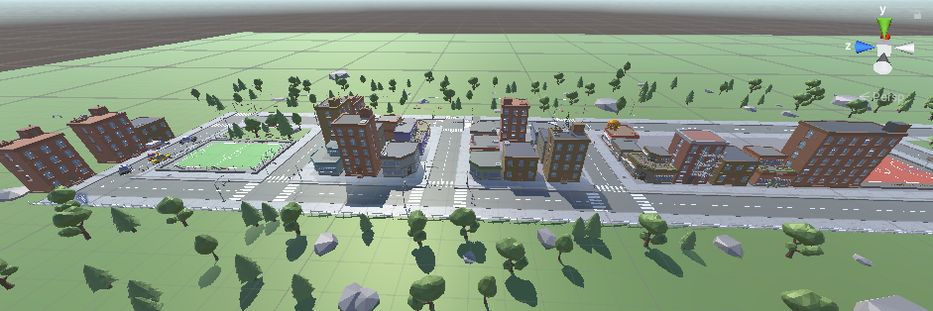

We designed our character and game map on the game canvas. The map we created was designed as a straight road going to infinity. Our character will run on this road with the user for a certain time. For the map we prepared, assets were purchased from the unity asset store.Our character is taken from the unity asset store and placed in our game.

[2]: IMPLEMENT THE PLAYER INTO MAP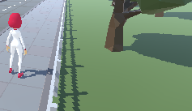

Scale and rotation are adjusted while adding the player to the designed map. Light and camera settings have been defined for the player who will run backward. Thanks to these settings, the camera will follow the player and the player will be able to be displayed continuously on the game screen.

The animation controller panel has been created for animations that vary according to the player's speed level. In this way, the player whose speed level drops, can stop suddenly while running or start running while walking.

[3]: ANIMATION CONTROLLER DESIGNING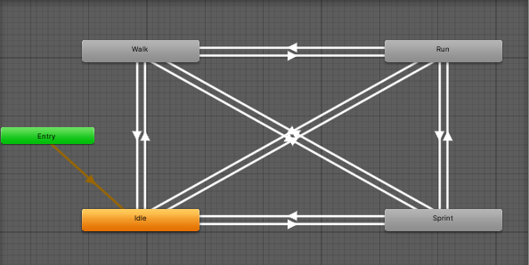

Animation controls for our character have been prepared and integrated into the player. Thus, our character will change its animation according to the speed of the user.

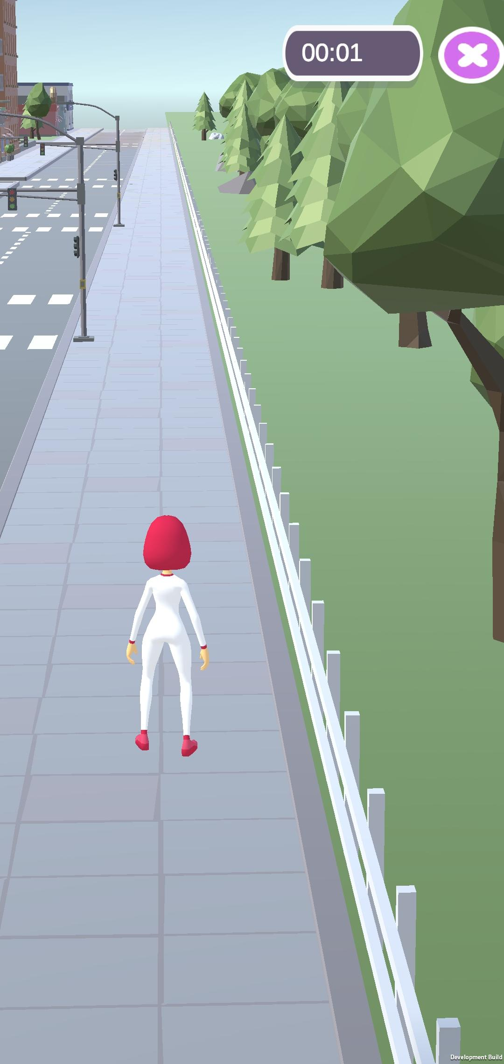 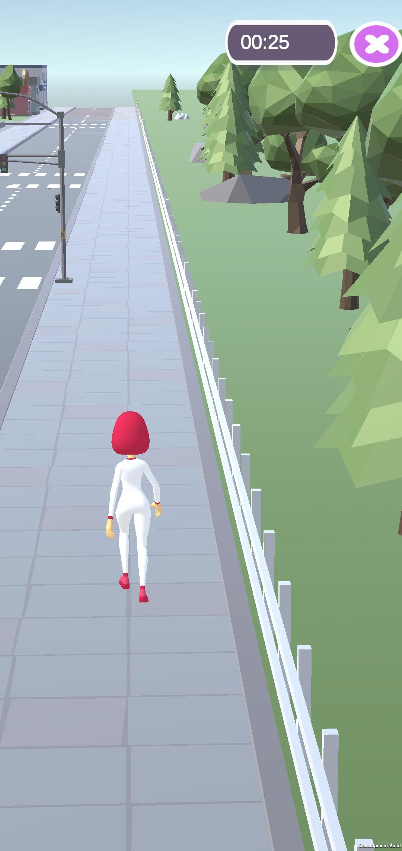 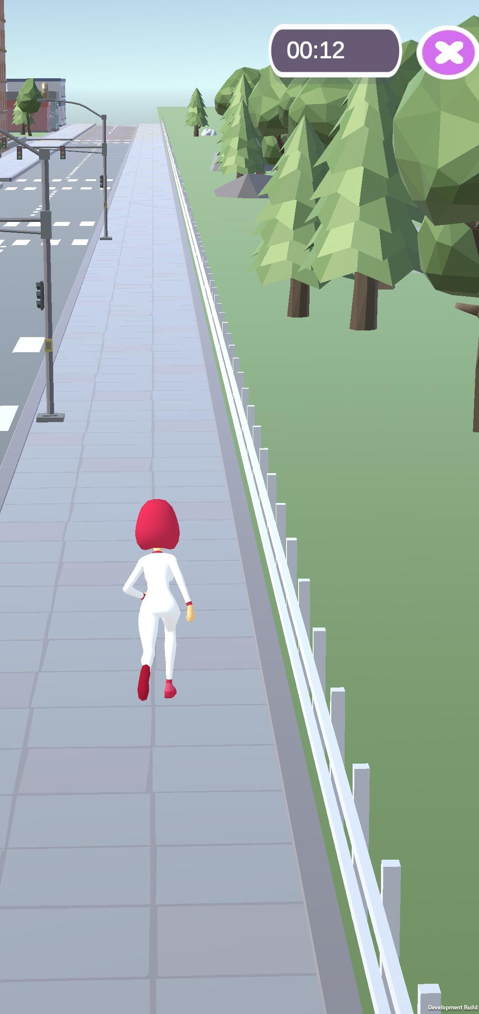

IDLE WALK RUN

**2.1.2 Main Menu and Control The Sensors Canvas**

Accelerometer and gyroscope are needed to collect data in the background of the game and predict the speed level. While the accelerometer is found in almost every device, the gyroscope is a rarer sensor. For this reason, whether the device has a gyroscope or not is checked on the home screen of the game. If the device does not have a gyroscope, the user is informed and the game is closed.

[4]: IF GYROSCOPE NOT EXISTS 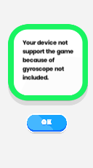

The name of the game and the inside of the game were used to design an image entry screen. Added to meet the user in the game login screen in case of a gyroscope. In addition, a button to launch the game and an information button that guides the user to a page indicating that our game is supported by TUBİTAK have been placed.

[5]: MAIN MENU [6]: INFORMATION ABOUT PROJECT 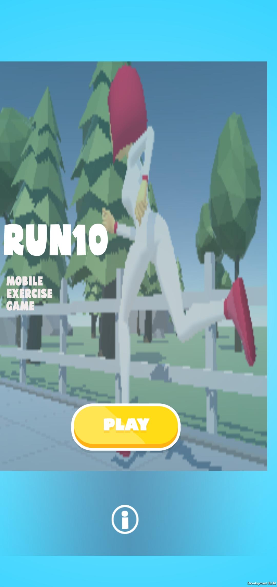 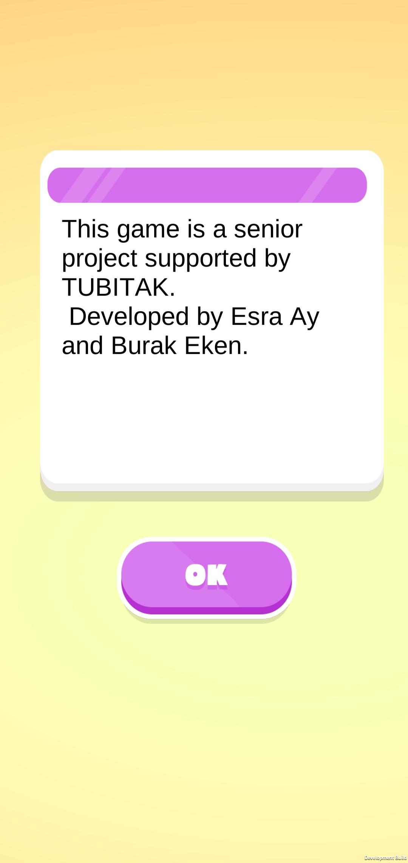

**2.1.3 Pause Game Canvas**

During the game, we switch to this screen with the pause button in the upper right corner. Thanks to this screen, the user can return to the main menu, leave the game, resume the game or restart.

[8]: PAUSE CANVAS 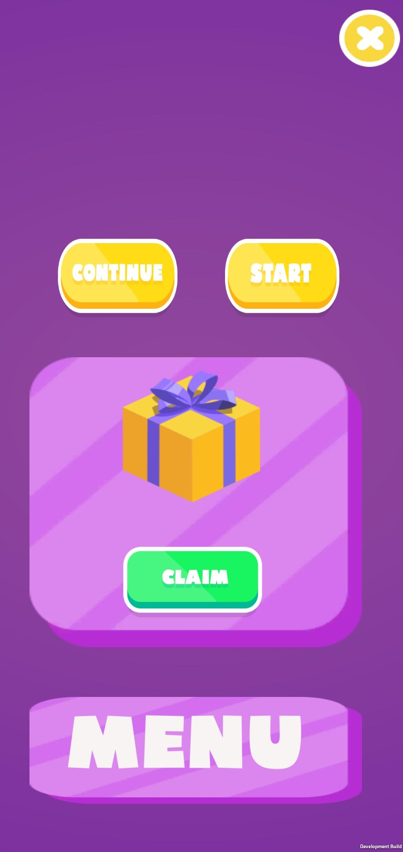

**2.1.4 End Game Canvas**

At the end of the game, the user encounters this canvas. On this screen, the user displays the score collected. There are also two buttons to return to the main menu and start the game again.

[7]: END OF THE GAME 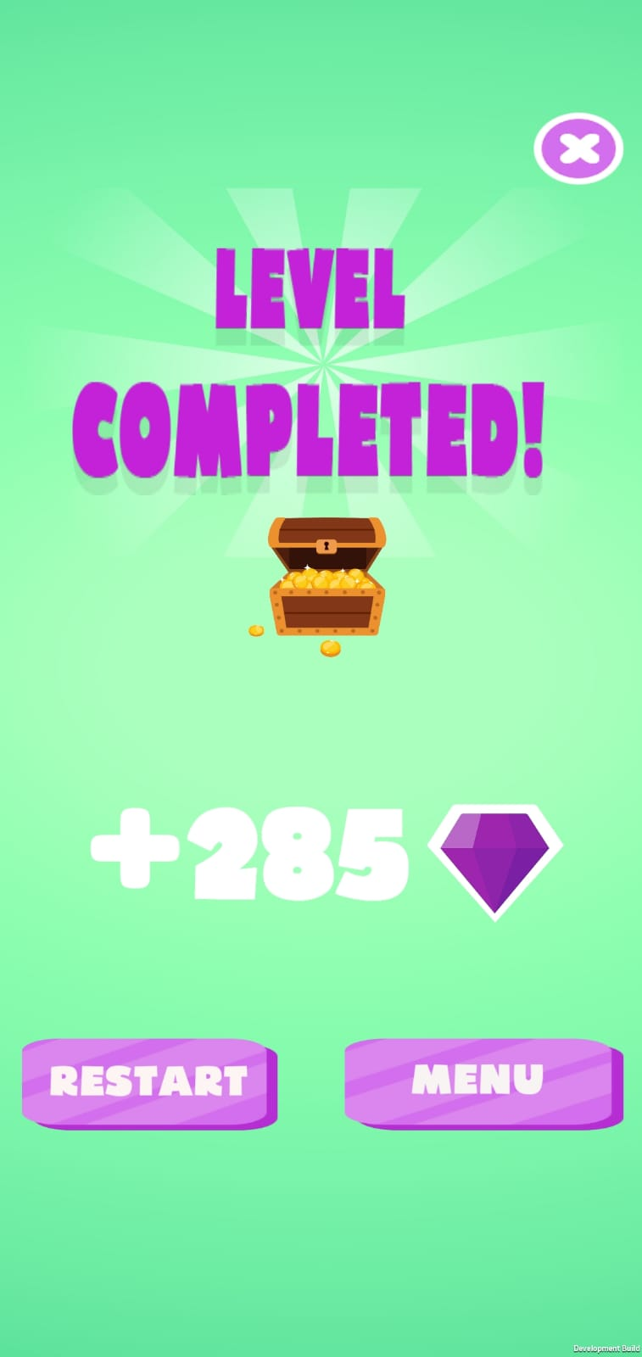

## 2.2.Machine Learning Phase

### **2.2.1 Collecting Data and Creating Train Dataset**

Data collection is completed with an externally installed application. At this stage, data were collected separately for each speed stage determined and recorded in CSV format. Then R Studio was used in the whole study. The purpose of this is that R Studion is useful in data processing. All the data received were combined into tables and a function was written to normalize the data so that the average values of the activity performed in small time intervals were calculated and made suitable for classification.

### **2.2.2 Classification**

Classification operations were made in R Studio using the created train dataset. Firstly, imputation was performed on the data and the data was reserved for use as train (70%) and test (30%). Then KNN, NAIVE BAYES, and DECISION TREE models were prepared with the train dataset. The success rate is over 70% in all models. Then prediction was made according to the models created using the test dataset. Although the most successful model in Prediction is Naive Bayes, the sensitivity value was found low. It is determined that the classifications that will best match our game are KNN and Decision Tree.With this classification process codes and detailed studies, a report was prepared with RStudio .rmd file. You can find it in Machine Learning Reports file with two different alternatives (.html, .doc). You can open the files by downloading them.

### **2.2.3 Classification in Unity**

The research was done to classify in Unity. As a result of this research, the use of ready-made plugins was stopped to improve the performance of the game and the algorithms written were examined. A script that dynamically collects and processes data was prepared (Accelerometer.cs). A script that can classify dynamically collected data according to the train data previously prepared in the KNN algorithm was investigated. As a result of the research, the most appropriate classification codes were found through GitHub and all permissions and rights were obtained from the person who prepared it. With no definitive decision, the KNN script was integrated into the barber game.

github link for KNN: https: //github.com/zeved/KNN/tree/master/KNN

# Results

As a result, the goals set to complete the project have been achieved. In real life, it was carried out using machine learning and game programming skills in accordance with the machine purpose.

With the budget provided by Tubitak, device deficiencies are completed and in-game assets are purchased. In this way, the design was taken to an advanced level. Thanks to the applied classification algorithm, the speed of the user has been reduced to 8 levels and estimated. The determined speed level is matched with the in-game animation and adapted to the game. With the completion of the remaining screens, a mobile game has been developed that synchronizes in real-time and detects exactly the right move. In our project, which aims to make exercise more fun for the user, the user can improve himself day by day, break his own records, and make exercise a part of his daily life.

# Conclusion

We believe that our project will minimize the insufficiency of physical activity that has become a major problem in the world. While doing this, our primary goal is to enable our users to exercise in the environment they want and thus encourage them. Our game will be easily available to every device and by any age audience. In this way, it is planned to become a part of our daily life and increase physical activity.

# References

[1]<http://www.journalagent.com/turkhijyen/pdfs/THDBD_70_4_205_214.pdf>

[2]<https://www.memorial.com.tr/saglik-rehberleri/hareketsiz-yasam-metabolik-sendrom-nedeni/>

[3]<https://docs.unity3d.com/ScriptReference/LocationService.html>

[4]<https://docs.unity3d.com/ScriptReference/Input-acceleration.html>

[5]<https://www.gigadrillgames.com/2017/04/16/pedometer-plugin-version-1-5-for-unity3d/>